SIMATS ENGINEERING (SAVEETHA SCHOOL OF ENGINEERING)
Department of Computer Science and Engineering
CO1 ASSESSMENT TOOL 1 – Case Study Analysis
Course Code: | CSA10 / CSA1004 | Course Title: | Software Engineering
CO Assessed: | CO1 | Assessment: | Assessment Tool 1 – Case Study Analysis
Weightage: | 20% | Total Marks: | 25
CO1 Statement: | Apply advanced methodologies and agile project management techniques to manage software projects effectively
Student Name: | Amburi Manasa | Reg. No.: | 192372311
Date: | 10.10.2026 | Duration: | 60 minutes

Code of Conduct
I Amburi Manasa/192372311 (Name/RegNo) certify that this submission is my original work and that I have adhered to the guidelines specified for this assessment. I understand that any violation of academic integrity rules will result in disciplinary action.
Signature of the Student: Amburi Manasa

Case Study Analysis: Intelligent Traffic Violation Management System
1. Understanding the Problem Statement
Urban traffic authorities must monitor violations such as signal jumping, overspeeding, illegal parking and lane violations across a large road network. Manual enforcement depends on officers being present at the right place and time, is resource-intensive and cannot give complete coverage. Many violations therefore go unrecorded, notices are issued late, and records are kept in separate registers. The task is to design one integrated system that connects camera-based monitoring with traffic databases to detect and record violations, keep evidence, issue electronic notices and give authorities analytics.
Objectives: monitor traffic using cameras, detect predefined violations, record violation evidence, identify the vehicles associated with violations, generate electronic violation notices, maintain violation histories, provide traffic violation analytics and support authorized administrative actions.
Scope: the system covers camera monitoring, violation detection, evidence storage, vehicle identification, notice generation, violation history and analytics for a city traffic authority. Road construction, vehicle manufacturing, driver training and full court case management are outside its scope.
2. Key Stakeholders and Challenges
- Vehicle owners/drivers: view notices, check violation details and evidence, pay fines and raise disputes.
- Traffic police officers: monitor cameras, verify flagged violations and take enforcement action.
- System administrators: manage users, camera settings, violation rules and notice approvals.
- Traffic authority management: view analytics on violations, hotspots and trends to plan enforcement and road safety measures.
- Transport department and payment gateways: supply vehicle registration and owner details and process fine payments.
Each stakeholder depends on the others: a missed detection affects the evidence record, which affects the notice sent to the owner, which affects fine collection and the data used by management. The system must therefore serve all of them from the same data.
Challenges: manual enforcement gives limited coverage; officers cannot be present at every junction; evidence is not always captured or stored securely; identifying vehicles and owners takes time; notices are delayed or sent to wrong addresses; false detections can lead to disputes; and managers lack timely data for decisions. Together these problems reduce enforcement efficiency, delay penalties and weaken traffic safety.
3. Analysis of the Current Approach
Many authorities rely on officers on the road, handheld devices or standalone cameras reviewed manually, paper challan books and separate registers or spreadsheets for violation records. Its strengths are low technology cost, familiarity to officers, on-the-spot action and little training. Its limitations are far greater: coverage is partial, evidence is incomplete or lost, vehicle identification is slow, records are duplicated and inconsistent, notices are posted late, violation history is hard to retrieve and reports must be compiled by hand. The main gap is the lack of a single, automated and centralized source of violation data shared by all departments.
Other gaps include no automatic link between detection and notice generation, no tracking of notice status or payment, and no analytics on violation patterns and locations. These gaps directly produce the delays, missed violations and disputes described in the problem statement.
4. Proposed Software Solution
The proposed solution is a web-based application with a central database, camera integration and role-based access for officers, administrators and vehicle owners. Its major modules are:
- Camera Monitoring: camera registration, live video or image feed and location mapping.
- Violation Detection: rule-based and image-processing detection of signal jumping, overspeeding, illegal parking and lane violations.
- Evidence Management: capture and secure storage of images, video clips, timestamp and location.
- Vehicle Identification: number plate recognition and lookup of owner details in the vehicle database.
- E-Notice Generation: automatic notice creation, fine calculation and delivery by email or SMS.
- Violation History: record of past violations per vehicle, payments and disputes.
- Analytics and Administration: dashboards on violation types, hotspots, time trends and revenue.
Functional requirements: cameras feed data to the system, violations are detected and flagged, evidence is stored, vehicles are identified, officers verify and approve cases, notices are generated, owners can view and pay fines, and authorities can view reports. Violation histories are stored so that repeat offenders can be identified.
Each module exposes its data through well-defined interfaces, so a change in violation rules or fine amounts does not affect camera monitoring or evidence storage. A single relational database stores cameras, violations, evidence references, vehicles, notices, payments and users, and role-based dashboards show each user only what they need.
The system follows a three-tier architecture: a presentation layer (web screens), a business logic layer (violation rules, vehicle matching, fine calculation) and a data layer. Notifications by email or SMS deliver notices, alert officers about cases awaiting verification and remind owners of pending fines.
Non-functional requirements: response time under three seconds for user actions, 99.5% availability, data encryption, support for concurrent cameras and users, a simple interface, tamper-proof evidence and daily backups.
Software engineering principles: Modularity is achieved by separate, loosely coupled modules with defined interfaces. Scalability comes from a layered, cloud-deployable architecture that can add cameras or junctions. Maintainability is supported by clean code, documentation and version control. Reliability uses human verification of flagged cases, transaction control and backups. Usability is provided through role-specific, easy screens. Security uses authentication, role-based access, encrypted evidence and payments, and audit logs.
5. Chosen Methodology: Agile (Scrum)
Scrum is selected because traffic rules, detection accuracy and notice formats are likely to change as officers and administrators give feedback, and the system has clearly separable modules. Development is divided into two-to-three-week sprints, with camera monitoring and violation detection delivered first, followed by evidence management, vehicle identification, notice generation and analytics. Each sprint ends with a working increment that traffic officers can review, so errors are found early and the product matches real needs. Waterfall would be too rigid for changing requirements, and Scrum's regular reviews, retrospectives and automated testing also make later maintenance and enhancement easier.
The product owner (traffic authority representative), Scrum master and development team work together through sprint planning, daily stand-ups and sprint reviews. A prioritised product backlog keeps the most valuable features first, and continuous integration with automated tests keeps the system reliable after every change.
For maintenance, the backlog continues after release, so new requests such as a new violation type or a revised fine rule can be added in later sprints without redesigning the system. Regular retrospectives help the team improve its process, and user stories written in the officer's or vehicle owner's words keep development focused on real needs.
6. Expected Outcomes and Limitations
Benefits: improved traffic law enforcement, reduced dependence on manual monitoring, faster violation processing, centralized violation records, improved traffic safety and better traffic management decisions. Central data and automated detection address each challenge identified earlier, and analytics supports better enforcement planning and road safety decisions.
Specifically, camera-based detection addresses limited coverage, secure evidence storage addresses lost or disputed proof, vehicle database integration addresses slow identification, and automatic e-notices address delayed penalties. Success can be measured through the number of violations detected, shorter notice processing time, fewer disputes and a reduction in repeat violations.
Risks and limitations: false or missed detections in poor lighting or weather, number plate recognition errors, outdated vehicle database records, data privacy obligations, camera or network downtime and integration with existing transport and payment systems. Initial development, camera installation and training also require investment. These risks can be reduced through officer verification before notice approval, regular camera maintenance, data updates, a backup server and compliance with data-protection rules.
Future enhancements: AI-based detection with higher accuracy, predictive analytics for accident-prone areas, adaptive signal control, mobile app for owners, integration with national vehicle databases and automated helmet or seat-belt violation detection.
Conclusion
The Intelligent Traffic Violation Management System replaces manual and disconnected enforcement with one integrated platform. By applying modular design, strong security and an Agile Scrum process, the authority can detect violations more completely, keep reliable evidence, issue notices quickly and make better traffic management decisions. The system is therefore a practical, scalable and maintainable solution that improves both traffic enforcement and road safety.

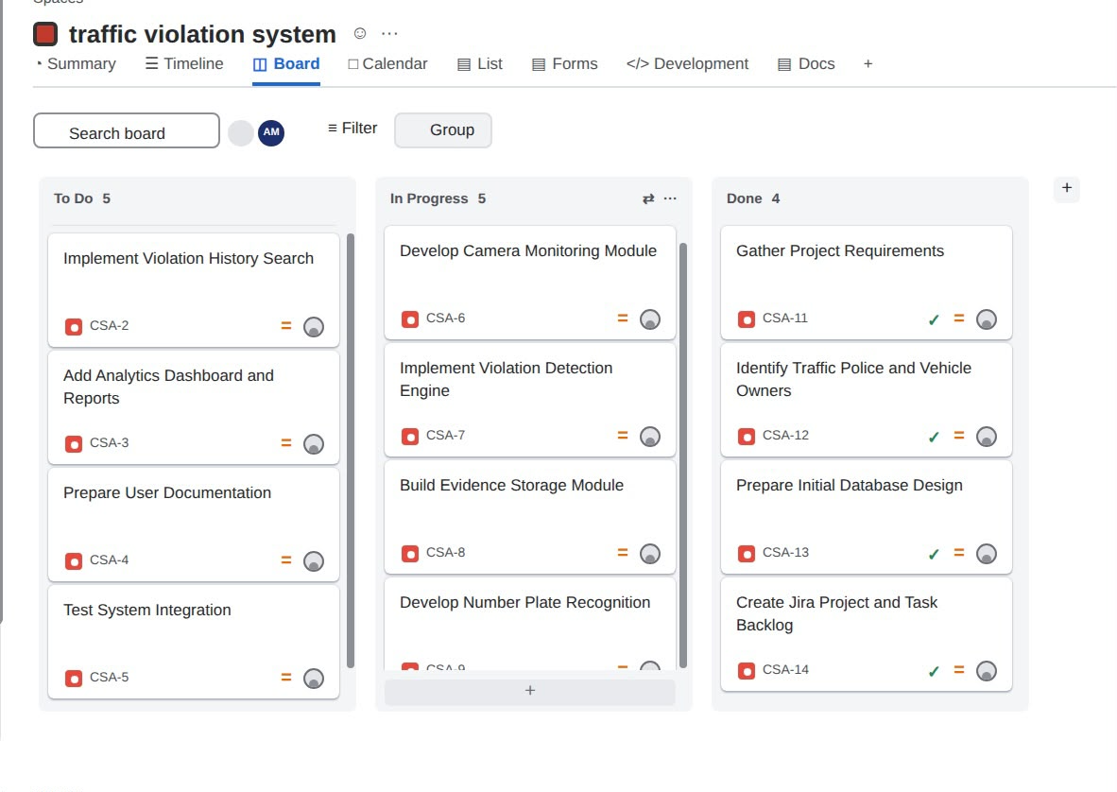
Rubrics for Calculation
Criteria | Excellent (5 Marks) | Good (3 Marks) | Satisfactory (2 Marks) | Needs Improvement (1 Mark)
Problem Understanding (30%) | Clearly explains the problem, objectives, and scope with complete understanding. | Explains the problem with minor omissions. | Basic understanding with limited explanation. | Poor understanding; objectives and scope are unclear or missing.
Stakeholder & Challenge Analysis (25%) | Identifies all stakeholders, their roles, and challenges with clear analysis. | Identifies most stakeholders and challenges with adequate analysis. | Identifies only a few stakeholders or challenges. | Stakeholders and system analysis are incomplete or inaccurate.
Current System Analysis (20%) | Thoroughly analyzes the existing system, strengths, weaknesses, and identifies all gaps. | Good analysis with most strengths and weaknesses identified. | Limited analysis with partial identification of issues. | Proposed solution is unclear or inappropriate; requirements are largely missing.
Proposed Software Solution & Software Engineering Principles (15%) | Proposes an innovative, feasible solution applying appropriate software engineering principles (modularity, scalability, maintainability, security, etc.). | Suitable solution with good application of software engineering principles. | Basic solution with limited application of software engineering principles. | Methodology is inappropriate, poorly justified, or not discussed.
Methodology/ Framework Justification (10%) | Selects the most suitable SDLC/model/framework and provides strong technical justification. | Suitable methodology selected with adequate justification. | Methodology selected but justification is weak. | Outcomes, limitations, or future enhancements are missing; report lacks organization and clarity.

Criteria | Mark
Problem Understanding (30%) | /5
Stakeholder & Challenge Analysis (25%) | /5
Current System Analysis (20%) | /5
Proposed Software Solution & Software Engineering Principles (15%) | /5
Methodology/ Framework Justification (10%) | /5
TOTAL | /25

